# Experiment 03

# Code:

# 

# Naïve bayes

import numpy as np

import matplotlib.pyplot as plt

import pandas as pd

dataset=pd.read_csv('diabetes.csv')

X= dataset.iloc[:,:-1].values

y= dataset.iloc[:,-1].values

from sklearn.model_selection import train_test_split

X_train,X_test,y_train,y_test=train_test_split(X,y,test_size=0.2,random_state=0)

from sklearn.naive_bayes import GaussianNB

from sklearn.metrics import accuracy_score,confusion_matrix

clf1 = GaussianNB()

clf1.fit(X_train, y_train)

predicted1 = clf1.predict(X_test)

accuracy1 = accuracy_score(predicted1,y_test)

print('Accuracy_score=',accuracy1

from sklearn.metrics._plot.confusion_matrix import ConfusionMatrixDisplay

lables=[0,1]

cm1=confusion_matrix(y_test,predicted1,labels=lables)

disp1=ConfusionMatrixDisplay(confusion_matrix=cm1,display_labels=lables)

disp1.plot()

**Output:**

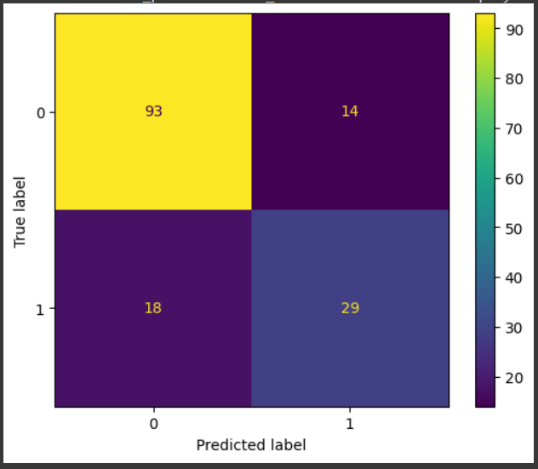

import numpy as np

import matplotlib.pyplot as plt

from sklearn.metrics import roc_curve, roc_auc_score, auc

fpr, tpr, thresholds = roc_curve(y_test, predicted1)

auroc = roc_auc_score(y_test, predicted1)

print(f"AUROC: {auroc}")



plt.figure(figsize=(8, 6))

plt.plot(fpr, tpr, color='darkorange', lw=2, label=f'AUROC = {auroc:.2f}')

plt.plot([0, 1], [0, 1], color='navy', lw=2, linestyle='--')

plt.xlim([0.0, 1.0])

plt.ylim([0.0, 1.05])

plt.xlabel('False Positive Rate')

plt.ylabel('True Positive Rate')

plt.title('Receiver Operating Characteristic (ROC) Curve')

plt.legend(loc='lower right')

plt.show()

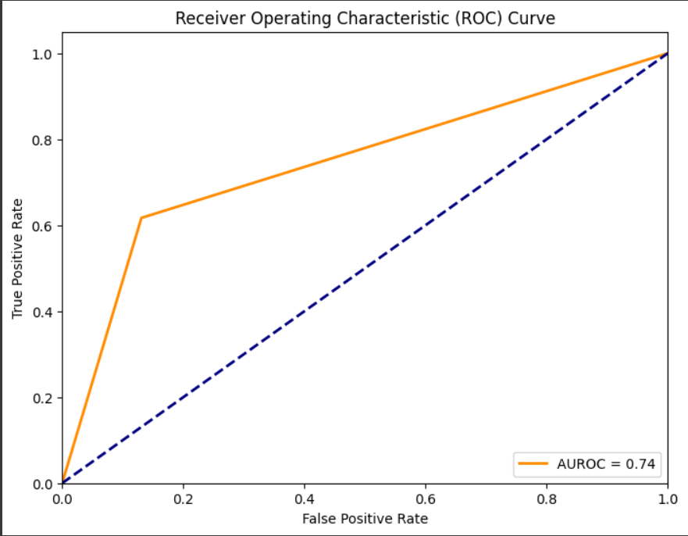

**Decision Tree**

from sklearn.tree import DecisionTreeClassifier

clf = DecisionTreeClassifier()

clf.fit(X_train,y_train)

DT_predicted=clf.predict(X_test)

DT1 = accuracy_score(DT_predicted, y_test)

print("Accuracy:", DT1)



labels = [0,1]

cm = confusion_matrix(y_test, DT_predicted, labels=labels)

disp = ConfusionMatrixDisplay(confusion_matrix=cm, display_labels=labels)

disp.plot()

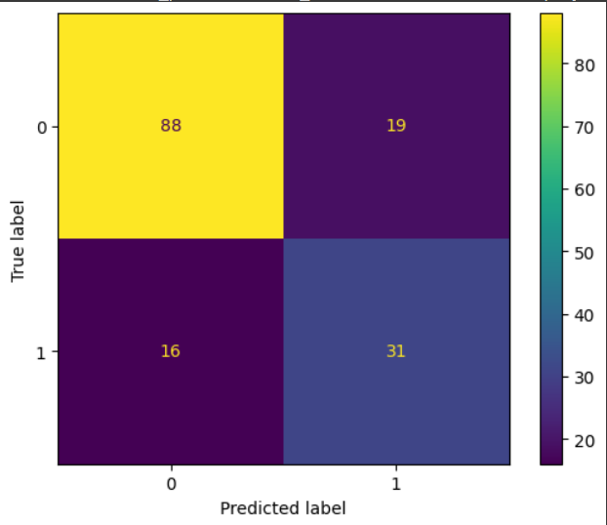

fpr, tpr, thresholds = roc_curve(y_test, predicted1)

auroc = roc_auc_score(y_test, DT_predicted)

print(f"AUROC: {auroc}")



**K Fold**

from sklearn.model_selection import KFold

from sklearn.model_selection import cross_val_score

kfold = KFold(n_splits = 10, shuffle = True , random_state=42)

scores = cross_val_score(clf1,X,y,cv=kfold,scoring='accuracy')

for i in scores:

  print(i)

